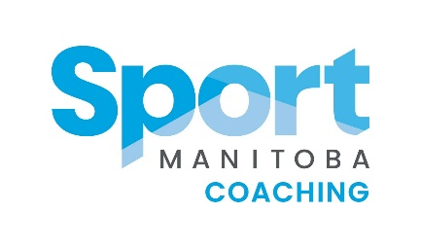
Sport Manitoba Coaching Female
Mentorship Program Mentee Application
Presented by Bison Transport

First Name: Click or tap here to enter text.
Last Name: Click or tap here to enter text.
NCCP # (if available): Click or tap here to enter text.
City: Click or tap here to enter text. Email Address: Click or tap here to enter text.
Primary sport coached: Click or tap here to enter text.

Please describe why you would like to be a part of the Female Mentorship Program.
Click or tap here to enter text.

What qualities are you looking for in a Mentor? Click or tap here to enter text.

What context of athletes do you coach?
☐ Fundamentals (approx. age 6-8)
☐ Learn to Train (approx. age 9-12)
☐ Train to Train (approx. age 11 – 16)
☐ Train to Compete (approx. age 15 – 23)

Years of Coaching Experience: (Must have a minimum of 1 year coaching)
☐ 1-2 years
☐ 3-5 years
☐ 6-9 years
☐ 10+ years

Preferred meeting style
☐ In person
☐ Online (i.e. Skype, Facetime, zoom, etc)
☐ Over the phone

Preferred Learning style (check all that apply to you)
☐ Visual
☐ Auditory
☐ Reading/Writing
☐ Kinesthetic

Top 3 topics you want to learn more about.
Click or tap here to enter text.

How much support do you expect to be able to receive from your Mentor coach?
☐ Connecting once a month. Primarily phone or email communication is fine.
☐ Connecting once or twice a month by email or phone. One in person meeting bi-monthly.
☐ Connecting 2+ times a month. More frequent in person meetings over the year. Attending a
practice or game.

What do you want to gain by the end of this program?
Click or tap here to enter text.

Anything else you would like us to know about you as a mentee?
Click or tap here to enter text.

