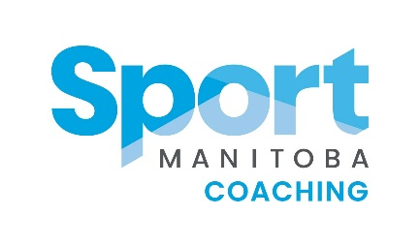

Sport Manitoba Coaching Female
Mentorship Program Mentor Application
Presented by Bison Transport
First Name: Click or tap here to enter text.
Last Name: Click or tap here to enter text.
NCCP # (if available): Click or tap here to enter text.
City: Click or tap here to enter text. Email Address: Click or tap here to enter text.
Primary sport coached: Click or tap here to enter text.

Please describe why you would like to be a part of the Sport Manitoba Coaching Female Mentorship Program.
Click or tap here to enter text.

Please indicate what kind of experience you have as a Mentor, if any? Click or tap here to enter text.

What context of athletes do you have the most experience coaching?
☐ Fundamentals (approx. age 6-8)
☐ Learn to Train (approx. age 9-12)
☐ Train to Train (approx. age 11 – 16)
☐ Train to Compete (approx. age 15 – 23)

Years of Coaching Experience: (Must have a minimum of 5 years coaching)
☐ 5-9 years
☐ 10+ years

Preferred meeting style
☐ In person
☐ Online
☐ Over the phone
☐ Other Click or tap here to enter text.

Mentoring style (check all that apply)
☐ Formal – set dates and times
☐ Informal – happens organically
☐ Situational – as needed
How much support do you predict you will be able to offer your Mentee coach(es)?
☐ Connecting once a month. Primarily phone or email communication is fine.
☐ Connecting once or twice a month by email or phone. One in person meeting bi-monthly.
☐ Connecting 2+ times a month. More frequent in person meetings over the year. Attending a
practice or game.

Please indicate which intake you would like to be a Mentor
☐ April Intake
☐ August Intake

How many Mentee Coaches would you be comfortable mentoring during the 2020/2021 year?
☐ One
☐ Two
☐ Three

Anything else you would like us to know about you as a mentor? Click or tap here to enter text.

