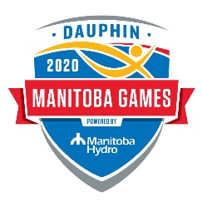
THANKS COACH!
Nomination Form

Information about your coach:

Full Name of Coach: Region:
Sport Coached: Name of Team/Athlete:
How long has the coach been coaching? How long with this Team/Athlete:
What other responsibilities does this coach have (i.e. occupation)?
Please answer each question in 150 words or less. You may use additional paper if necessary.
What contributions has this coach made to their sport and/or athlete(s)?

Describe any development or improvements his/her athlete(s) have demonstrated over time spent with this coach (either athletic or personal).

How does this coach demonstrate leadership (positive role modeling)? Be as specific as possible.

Overall, why do you think this coach should be selected in the Thanks Coach! program?

Information about you:
Your Name: Role at Games: _____________________________________
Date: Phone Number:

*Nominations sent in before the games must be received by Tuesday August 4, 2020
Nominations should be returned to:
Thanks Coach!
https://www.sportmanitoba.ca/coaching/recognition/thanks-coach/
To complete and submit an online nomination form.
Or Visit:

c/o Sport Manitoba Coaching
145 Pacific Avenue
Winnipeg, MB R3B 2Z6
Fax: 925-5624

At the Games: Nominations drop-boxes will be located at the Cafeteria, Athletes’ Village, and Youth Lounge or can be submitted directly online.
- Nominations for Phase 1 Coaches:
DEADLINE is Tuesday August 11, 2020 at 8:00pm
- Nominations for Phase 2 Coaches:
DEADLINE is Friday August 14, 2020 at 6:00pm

